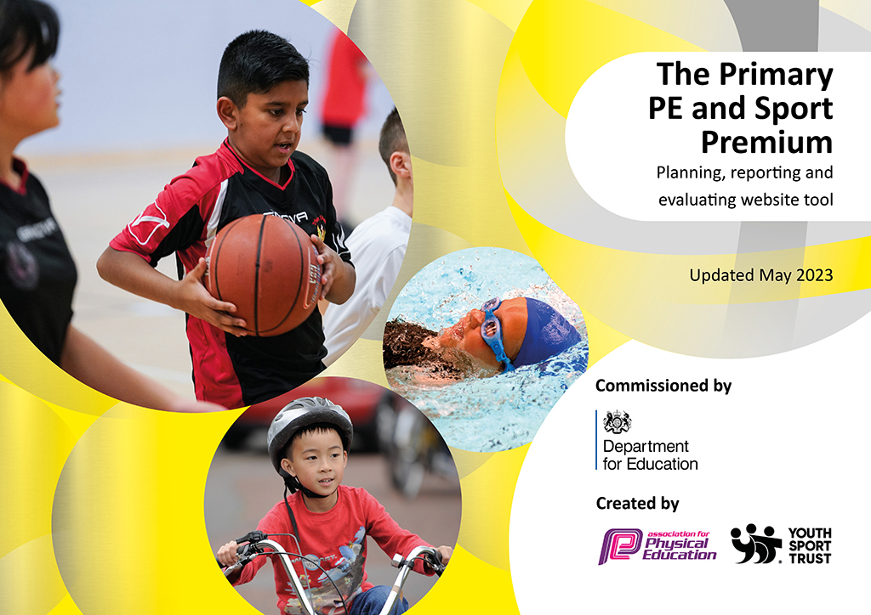
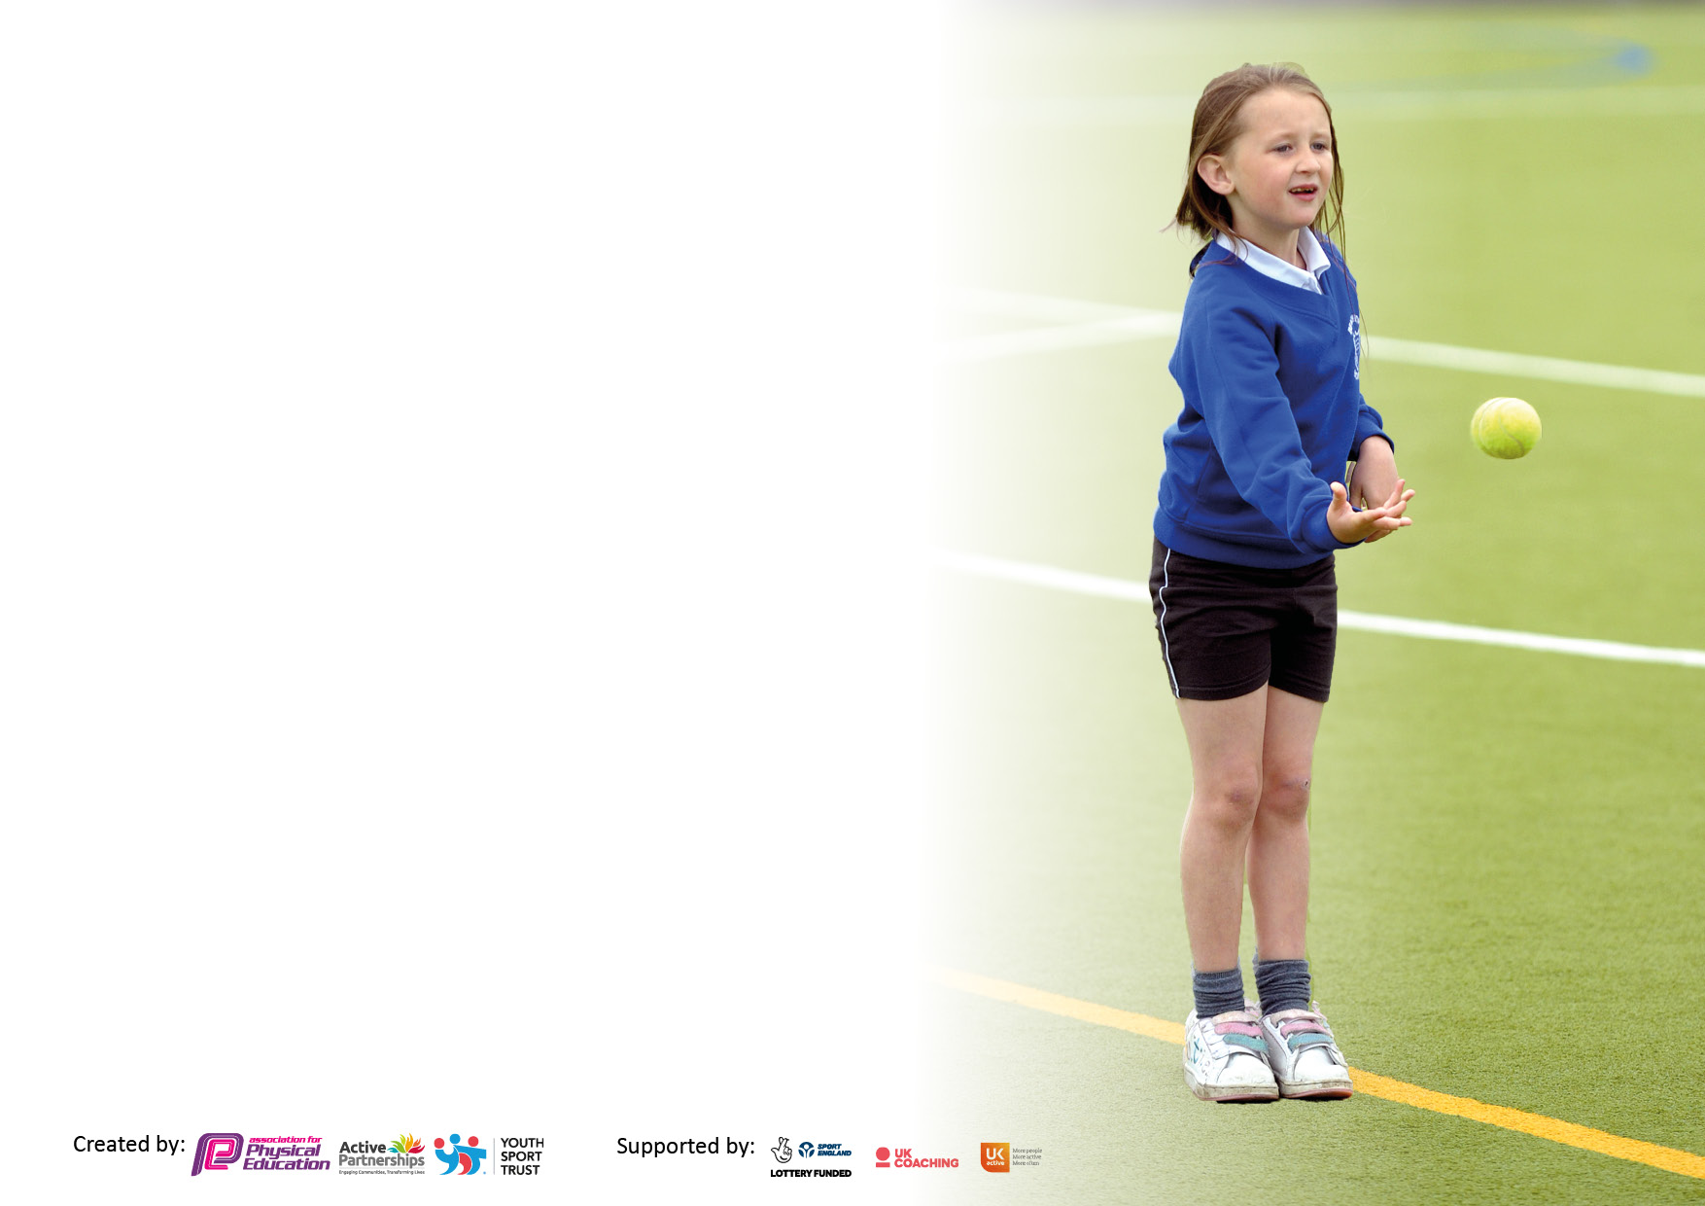

It is important that your grant is used effectively and based on school need. The Education Inspection Framework makes clear there will be a focus on ‘whether leaders and those responsible for governors all understand their respective roles and perform these in a way that enhances the effectiveness of the school’.

Under the Quality of Education Ofsted inspectors consider:
Intent - Curriculum design, coverage and appropriateness
Implementation - Curriculum delivery, Teaching (pedagogy) and Assessment
Impact - Attainment and progress

To assist schools with common transferable language this template has been developed to utilise the same three headings which should make your plans easily transferable between working documents.

Schools must use the funding to make additional and sustainable improvements to the quality of Physical Education, School Sport and Physical Activity (PESSPA) they offer. This means that you should use the Primary PE and sport premium to:

- Develop or add to the PESSPA activities that your school already offer
- Build capacity and capability within the school to ensure that improvements made now will benefit pupils joining the school in future years
- The Primary PE and sport premium should not be used to fund capital spend projects; the school’s budget should fund these.

Pleasevisitgov.ukfortherevisedDfEguidanceincludingthe5keyindicatorsacrosswhichschoolsshoulddemonstrate animprovement.Thisdocumentwillhelpyoutoreviewyourprovisionandtoreportyourspend.DfEencouragesschools to use this template as an effective way of meeting the reporting requirements of the Primary PE and Sport Premium.

We recommend you start by reflecting on the impact of current provision and reviewing the previous spend.

Schools are required to publish details of how they spend this funding, including any under-spend from 2021/2022, as well as on the impact it has on pupils’ PE and sport participation and attainment. All funding must be spent by 31st July 2023.

We recommend regularly updating the table and publishing it on your website throughout the year. This evidences your ongoing self-evaluation of how you are using the funding to secure maximum, sustainable impact. Final copy must be posted on your website by the end of the academic year and no later than the 31st July 2023. To see an example of how to complete the table please click HERE.

Details with regard to funding
Please complete the table below.

Total amount carried over from 2022/23 | £17,713
Total amount allocated for 2022/23 | £17,713
How much (if any) do you intend to carry over from this total fund into 2023/24? | £0
Total amount allocated for 2023/24 | £17,346
Total amount of funding for 2023/23. To be spent and reported on by 31st July 2024. | £17,346
Swimming Data
Please report on your Swimming Data below.

Meeting national curriculum requirements for swimming and water safety.  What percentage of your current Year 6 cohort perform safe self-rescue in different water-based situations?  N.B. Complete this section to your best ability. For example you might have practised safe self-rescue techniques on dry land which you can then transfer to the pool when school swimming restarts.  Due to exceptional circumstances priority should be given to ensuring that pupils can perform safe self-rescue even if they do not fully meet the first two requirements of the NC programme of study | 73%
What percentage of your current Year 6 cohort swim competently, confidently and proficiently over a distance of at least 25 metres?  N.B. Even though your pupils may swim in another year please report on their attainment on leaving primary school at the end of the summer term 2022.  Please see note above | 73%
What percentage of your current Year 6 cohort use a range of strokes effectively [for example, front crawl, backstroke and breaststroke]?  Please see note above | 73%
Schools can choose to use the Primary PE and sport premium to provide additional provision for swimming but this must be for activity over and above the national curriculum requirements. Have you used it in this way? | Yes

Action Plan and Budget Tracking
Capture your intended annual spend against the 5 key indicators. Clarify the success criteria and evidence of impact that you intend to measure to evaluate for pupils today and for the future.

Academic Year: 2023/24 | Total fund allocated: £17,346 | Date Updated:06.10.23
Key indicator 1: The engagement of all pupils in regular physical activity – Chief Medical Officers guidelines recommend that primary school pupils undertake at least 30 minutes of physical activity a day in school |  |  |  | Percentage of total allocation:
 |  |  |  | 52.43%
Intent | Implementation |  | Impact
Your school focus should be clear what you want the pupils to know and be able to do and about  what they need to learn and to  consolidate through practice: | Make sure your actions to achieve are linked to your intentions: | Funding allocated: | Evidence of impact: what do pupils now know and what can they now do? What has changed?: | Sustainability and suggested next steps:
Pupils set personal goals and targets for physical activity.  Pupils improve fitness and stamina.  More pupils engage in regular physical activity and know the benefits.  Pupil will know there is a wide range of sports and physical activities available to them outside of school.  All pupils will learn to swim and have secure basic life saving skills | Daily mile is timetabled into the school day for each cohort, pupils are encouraged to complete the 3 laps and record their personal bests.  Pupils who achieve the daily mile or make improvements are provided with a certificate.  Pupils who have not attended after school clubs before are engaged and actively targeted for sports clubs.  After school clubs engage more pupils in physical activity and offer a range of sports to engage pupils is activities they may not have access to.  All Key stage 2 classes are taught to swim and basic lifesaving skills. | £150 (target cards)  £35 (certificates)  Horse riding  £2,700  Multi Sports  £1,350  Football  £3,190  Swimming Y 3 – 5  £1,670 | Pupils are far more competitive and eager to participate in Daily Mile.  They set themselves challenging targets and improve their fitness and stamina.  More pupils are engaged in physical activity after school.  Pupilar are engaged in a wider range of after school clubs.  More pupils can swim at least 25m. | Pupils will build on their targets and plan for further targets next year.  Next Steps:  Pupils will build fitness and stamina year on year.  More pupils engage in after school clubs that offer physical activity  Next Steps:  Allocate further future funding to developing the after-school club provision.
Key indicator 2: The profile of PESSPA being raised across the school as a tool for whole school improvement |  |  |  | Percentage of total allocation:
 |  |  |  | 17.41%
Intent | Implementation |  | Impact
Your school focus should be clear what you want the pupils to know and be able to do and about  what they need to learn and to  consolidate through practice: | Make sure your actions to achieve are linked to your intentions: | Funding allocated: | Evidence of impact: what do pupils now know and what can they now do? What has changed?: | Sustainability and suggested next steps:
PE is recognised as a means for supporting good mental health along with physical wellbeing.  The Action Plan for PE has very clear measurable outcomes and these targets are also included in the whole school development plan.  The pupils are all set achievable and measurable targets, which are reviewed and developed throughout the year.  Extend the out of hours provision  .  All pupils will engage in outdoor adventure activities and promote off site learning. | PE activities are planned and yoga is embedded in all classes to address mental well-being as well as physical.  P.E leader to embed Get Set 4 PE planning across the whole school.  Targets will include personal goals for pupils to achieve. Pupils will review their targets termly.  CU lead will monitor the number of after school clubs they attend which includes physical activity.  Open the school for longer and widen the scope of physical activity provision. All clubs will be accredited by Children’s University  Outdoor adventure activities offsite will be planned for using local facilities.  Rock climbing for years 3 & 4, water activities for years 5 & 6.  Outdoor adventure activities offsite for KS1 children at Walton Park. | Awesome Walls £972  CLAC £1,440  Jungle Park  £609 | Pupils are engaged in further activities such as yoga and use this to calm or improve fitness levels.  The PE curriculum is embedded and pupils build on their skills each year.  Pupils build on previous targets and challenge themselves further.  More pupils engage in after school activities.  More pupils graduate from Children’s University.  Children are engaged in activities off site. | Next steps:  Yoga is embedded in the curriculum and all staff engage in teaching yoga  Pupils engage in yoga as a means for relaxation.  After school club provision encourages more pupils to engage in after school activity year on year.

Key indicator 3: Increased confidence, knowledge and skills of all staff in teaching PE and sport |  |  |  | Percentage of total allocation:
 |  |  |  | 14.84%
Intent | Implementation |  | Impact
Your school focus should be clear | Make sure your actions to | Funding | Evidence of impact: what do | Sustainability and suggested
what you want the pupils to know | achieve are linked to your | allocated: | pupils now know and what | next steps:
and be able to do and about | intentions: |  | can they now do? What has
what they need to learn and to |  |  | changed?
consolidate through practice:
Staff new to year group are more confident and competent in the teaching of gymnastics and dance.  Teaching staff are more competent in the assessment of PE. | Total Gymnastics coaches to be booked for Years 3, 4, 5 and 6.  Dance coach booked for Y1 to Y6.  Lesson observations demonstrations to be arranged with Sport leader for South Sefton Partnership. | Beth Tweddle Gym £1,275  Dance £1,300 | Pupils become more fluent and build on their gymnastic skills and knowledge. | Staff are effective in teaching Gymnastics and develop confidence to do so. The continue to teach effectively following the training.
Key indicator 4: Broader experience of a range of sports and activities offered to all pupils |  |  |  | Percentage of total allocation:
 |  |  |  | 11.53%
Intent | Implementation |  | Impact
Your school focus should be clear | Make sure your actions to | Funding | Evidence of impact: what do | Sustainability and suggested
what you want the pupils to know | achieve are linked to your | allocated: | pupils now know and what | next steps:
and be able to do and about | intentions: |  | can they now do? What has
what they need to learn and to |  |  | changed?
consolidate through practice:
Additional achievements:  Extend opportunities available to pupils other than sports covered in the curriculum, extend opportunities for competitive events.  Additional after school clubs to provide a wider range of sports to the younger pupils. | Buy into South Sefton Sport Partnership to ensure pupils are provided the opportunity to compete in various sporting events.  Ensure all pupils engage in off-site physical activity (see above – OOA)  Extend after school provision (see above) | South Sefton Partnership:  £2,000 | More pupils are engaged in a wider range of physical activities. | A wider range of sports are engaged in by the pupils.  Pupils are riding their bikes safely to school.  Pupils attend out of school clubs that school has introduced them too

Key indicator 5: Increased participation in competitive sport |  |  |  | Percentage of total allocation:
 |  |  |  | %
Intent | Implementation |  | Impact
Your school focus should be clear | Make sure your actions to | Funding | Evidence of impact: what do | Sustainability and suggested
what you want the pupils to know | achieve are linked to your | allocated: | pupils now know and what | next steps:
and be able to do and about | intentions: |  | can they now do? What has
what they need to learn and to |  |  | changed?:
consolidate through practice:
Pupils will be engaged in competitive sport and know that there are various competitive events and that these are measured in different ways, e.g running/athletics, games, personal targets. | Buy into South Sefton Sport Partnership to ensure pupils are provided the opportunity to compete in various sporting events.  Participate in the local football league and competition day  Run specific competitive events in school – World Cup Day, Athletics Day. |  | More children are becoming actively involved in competitive sport | Gold Games Mark achieved/Maintained.  More pupils are involved in competitive sport.

Signed off by |  | Date
Head Teacher: | Emma Murtagh | 05.10.23
Subject Leader: | Mrs K Crawford
Governor: | Mrs D. Haddock | 10.10.23

